15.62: (a)
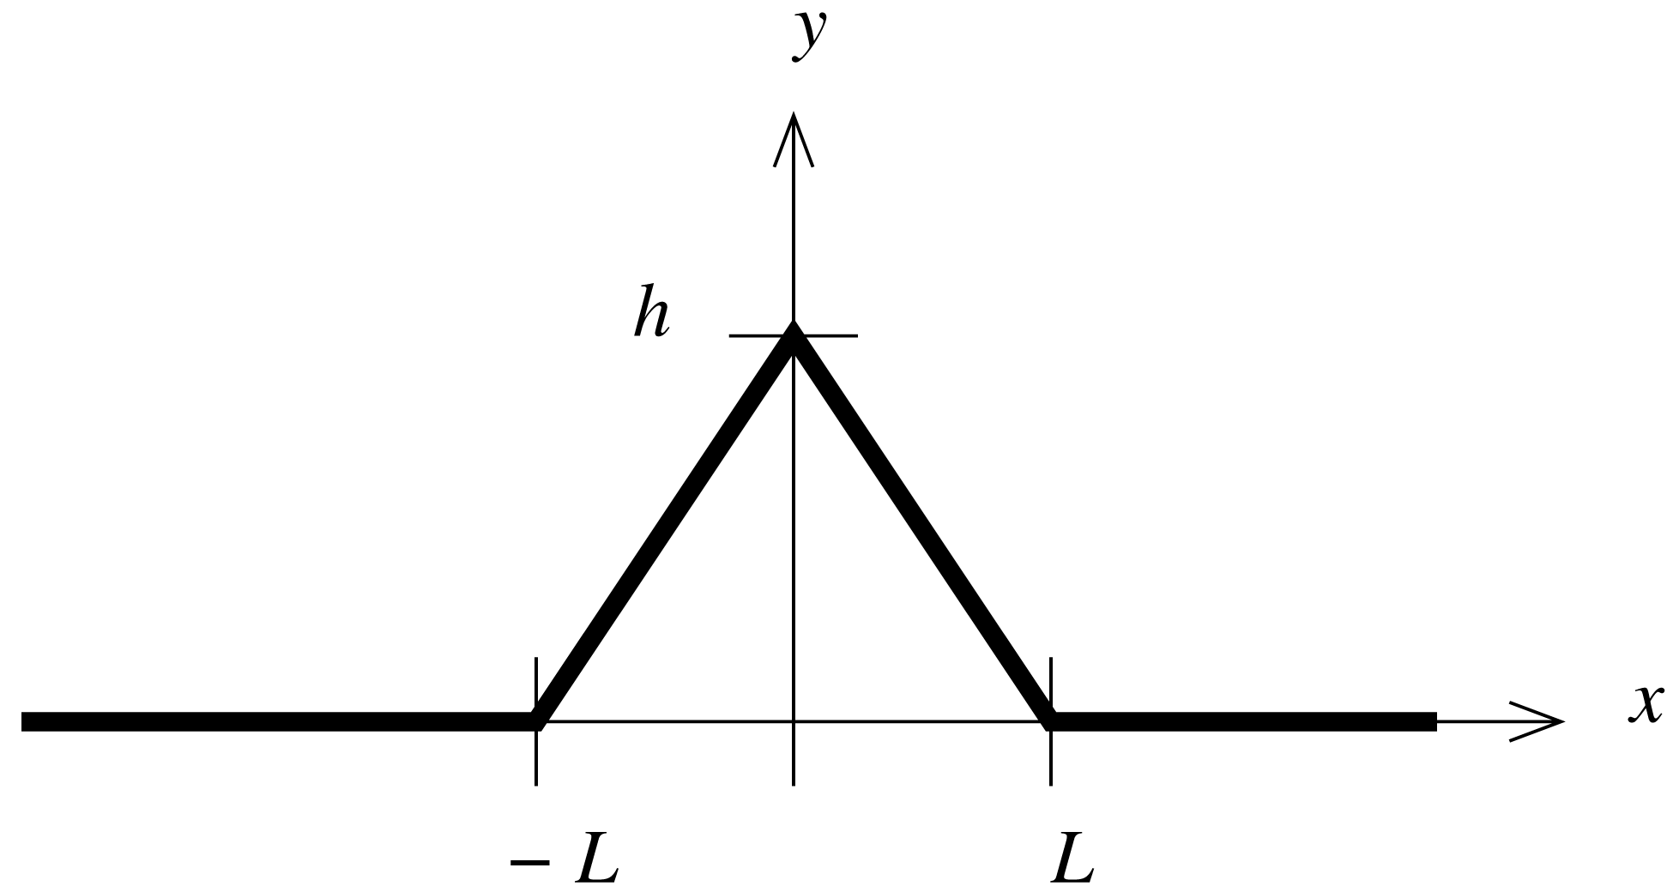

(b) The wave moves in the 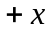direction with speed 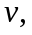 so in the expression for 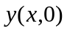 replace x with 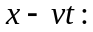

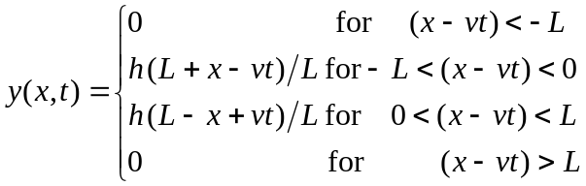

(c) From Eq. (15.21):

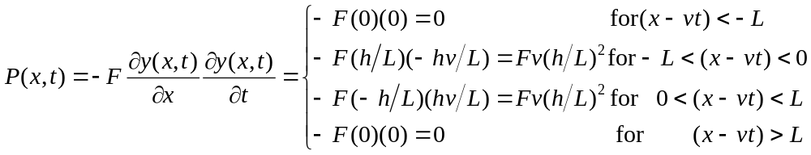

Thus the instantaneous power is zero except for 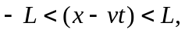 where it has the constant value 